## A Computational Fluid Dynamics (CFD) Analysis of the NACA 2412 Aerofoil to Determine Aerodynamic Performance and Stall Characteristics

**1. Introduction**

**Objective:** The primary goal of this article is to provide a comprehensive resource on the process of analysing an aerofoil using Computational Fluid Dynamics. We will investigate the aerodynamic performance of a NACA 2412 aerofoil across a range of angles of attack. The key objectives are:

* To determine the lift and drag characteristics.
* To identify the critical angle of attack at which the aerofoil stalls.
* To visualize the flow phenomena associated with lift generation and stall.
* To validate the simulation results against established theoretical and experimental data.

**Background:**

**Importance of aerofoils in engineering:**

Aerofoils play a crucial role in engineering, especially in aerospace, as they are the foundational shapes that generate **lift**—the upward force that allows aircraft to fly. The design of aerofoils determines how efficiently an aircraft can fly by optimizing the balance between **lift** and **drag** (the resisting force due to air).

Understanding concepts like **lift, drag, and stall** is fundamental to aircraft design:

* **Lift** must overcome the aircraft’s weight for it to become airborne.
* **Drag** must be minimized to ensure fuel efficiency and higher speeds.
* **Stall** occurs when the angle of attack becomes too steep, causing lift to drop suddenly—understanding and preventing stall is critical for flight safety and control.

To analyse these aerodynamic behaviours, engineers rely on **Computational Fluid Dynamics (CFD)**—a powerful simulation tool that models how air flows around complex shapes like aerofoils. CFD enables detailed virtual testing of lift, drag, and stall characteristics under various conditions, significantly reducing the need for expensive and time-consuming wind tunnel experiments. This accelerates the design process, improves accuracy, and allows rapid prototyping, making it an indispensable tool.

**2. Governing Equations: The Physics of Fluid Flow**

**Introduction to the Navier-Stokes Equations:** All fluid flow is governed by fundamental physical principles: **conservation of mass, momentum, and energy**. These principles are mathematically expressed through the **Navier-Stokes equations**, which are the foundation of fluid dynamics. They can be thought of as the fluid equivalent of **Newton’s Second Law (F = ma)**, describing how the velocity of a fluid changes in response to forces acting on it.

**Equation (Tensor Form):**

Ρ (∂v/∂t ​+ v⋅∇ v ) = −∇p + ∇⋅T + f

* **Where:**
  + ρ(∂v/∂t​+v⋅∇v): Represents the inertia of the fluid (its tendency to resist changes in motion).
  + −∇p: Represents the pressure gradient force (fluid moves from high to low pressure).
  + ∇⋅T: Represents the viscous forces (the internal friction or "stickiness" of the fluid).
  + f: Represents external body forces (like gravity, which is often negligible in this type of analysis).

**The Challenge of Turbulence and the RANS Approach:** For most real-world flows, the flow is **turbulent**, meaning it is chaotic and contains swirling motions (eddies) of many different sizes. Solving the **Navier-Stokes equations** directly for turbulent flow—known as **Direct Numerical Simulation (DNS)**—requires enormous computational resources, making it impractical for most engineering applications.

To address this, engineers use the **Reynolds-Averaged Navier-Stokes (RANS)** method. This is a clever simplification where the flow properties are **averaged over time**, effectively smoothing out the chaotic turbulent fluctuations. This makes the equations much more manageable and **computationally solvable**, allowing engineers to analyse complex turbulent flows with far less computing power while still obtaining accurate and useful results.

**The Turbulence Model (Closure):** The **RANS method** introduces new unknowns related to turbulence, which require additional equations to solve—this is known as the **turbulence model**.

In this study, the **k-ω SST (Shear Stress Transport)** model was used. This is a **two-equation model** that solves for the **turbulent kinetic energy (k)** and the **specific dissipation rate (ω)**. It is widely used in aerospace applications due to its **accuracy in predicting flow separation**, which is a key factor in understanding and preventing **aerodynamic stall.**

**3. Simulation Setup (Methodology)**

**3.1. Geometry Definition**

* **Aerofoil Selection:** The aerofoil profile selected for this analysis is the NACA 2412 of chord length 142.085 mm ( or c).
* **Computational Domain:** A 2D C-grid computational domain was created to simulate the external flow around the aerofoil. The domain was designed to be large enough to prevent boundary interference with the aerofoil’s aerodynamics.

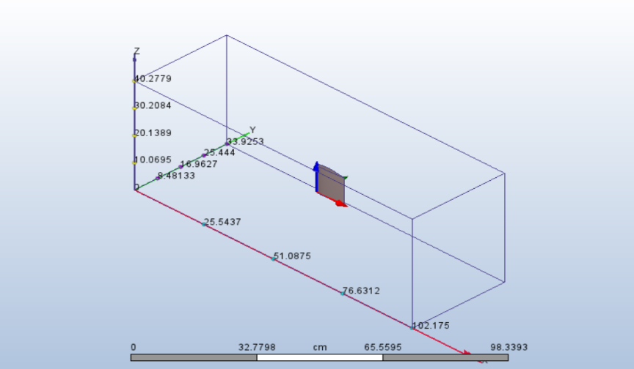

* **Dimensions:** Upstream Distance: The distance from the front of the aerofoil (leading edge) to the inlet where the flow enters ( 3.1c ).

Downstream Distance: The distance from the back of the aerofoil (trailing edge) to the outlet where the flow exits and the wake forms ( 2.8c ).

Top/Bottom Distance: The distance from the top and bottom surfaces of the aerofoil to the top and bottom boundaries of the domain ( 1.4c ).

* **Mesh Generation**

**Strategy:** A non-uniform mesh was generated, with a high density of cells concentrated near the aerofoil surface and in the wake region, where flow gradients are highest. The mesh becomes progressively coarser towards the far-field boundaries.

* **Inflation Layers:** To accurately resolve the boundary layer, **inflation layers** were added to the aerofoil surface. This is critical for the correct prediction of skin friction drag and flow separation.

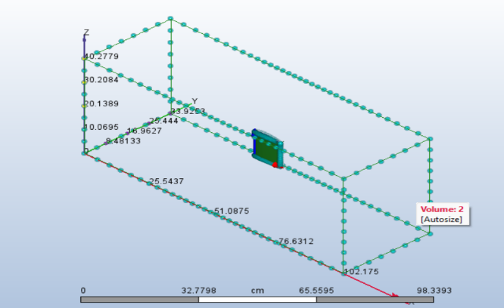 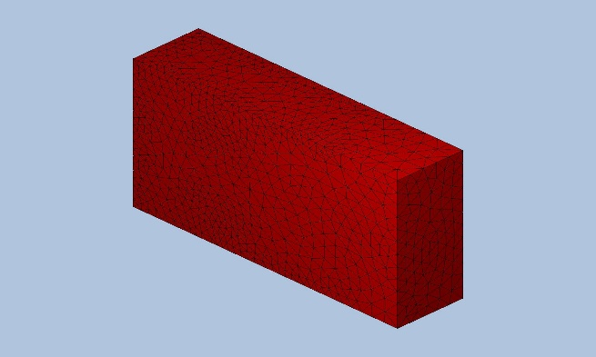

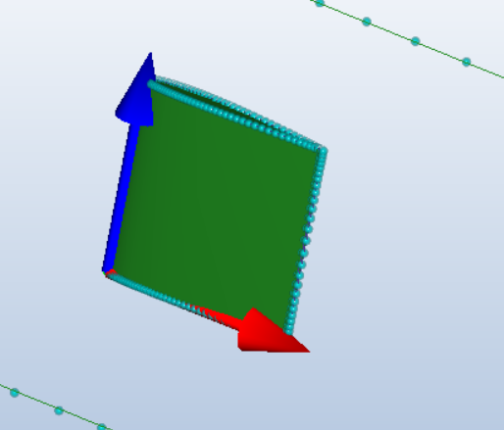 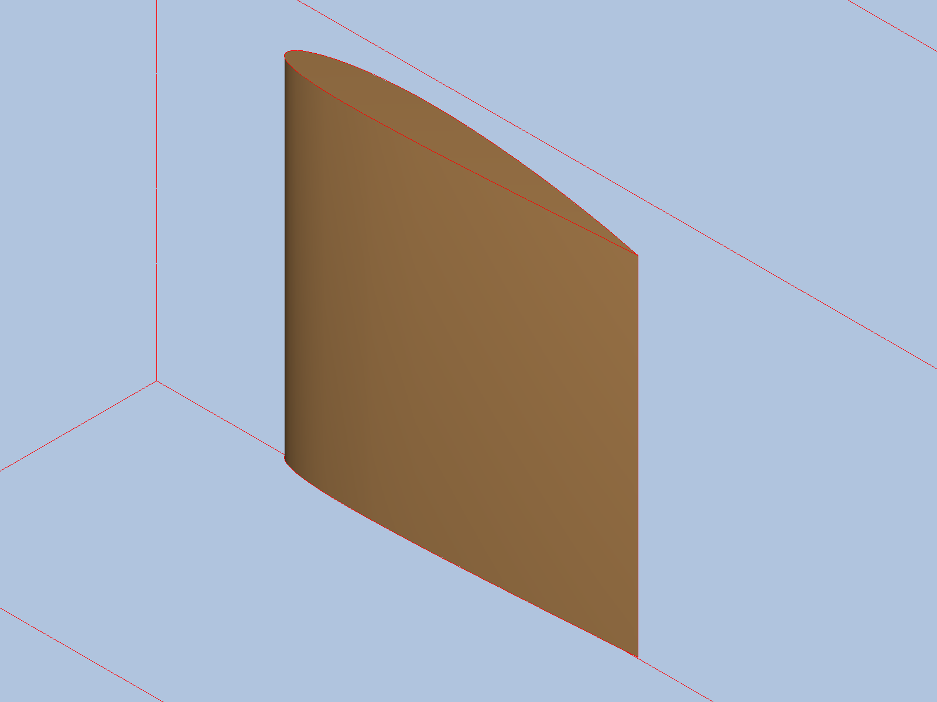Fine detail of the inflation layers around the aerofoil's edges and the fluid domain .

**Mesh Statistics Table:**

#### **Automatic Meshing Settings**

|  |  |
| --- | --- |
| Surface refinement | False |
| Gap refinement | False |
| Resolution factor | 1.0 |
| Edge growth rate | 1.1 |
| Minimum points on edge | 2 |
| Points on longest edge | 10 |
| Surface limiting aspect ratio | 20 |

#### **Mesh Enhancement Settings**

|  |  |
| --- | --- |
| Mesh enhancement | True |
| Enhancement blending | False |
| Number of layers | 3 |
| Layer factor | 0.45 |
| Layer gradation | 0.0 |

|  |  |
| --- | --- |
| Number of Nodes | 21041 |
| Number of Elements | 87772 |

**3.3. Boundary Conditions and Solver Settings**

* **Fluid Properties:** The working fluid was defined as Air at standard sea-level conditions.

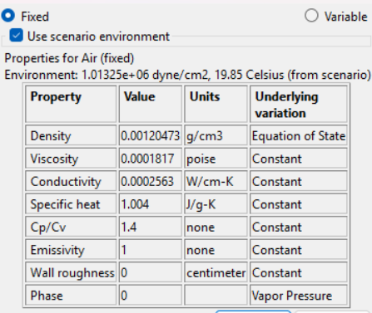

* **Freestream Conditions:** The simulation was run at a freestream velocity of 50 m/s over a 1-meter chord, corresponding to a Reynolds Number (Re) of approximately 3.4 million.
* **Boundary Conditions Table:**

|  |  |
| --- | --- |
| Type | ASSIGNED TO |
| Velocity Normal (0 m/s) | Surface:6 |
| Slip/Symmetry | Surface:6  Surface:7  Surface:9  Surface:10  Surface:11 |
| Pressure (0 Pa Gage) | Surface:8 |
| Velocity Normal (50 m/s) | Surface:10 |

**Solver Settings:** "A pressure-based, steady-state solver was used. The simulation was considered converged when residuals dropped below 10−4 and the lift and drag forces reached stable, constant values."

### **Solver Settings:**

|  |  |
| --- | --- |
| Solution mode | Steady State |
| Solver computer | MyComputer |
| Intelligent solution control | On |
| Advection scheme | ADV 5 |
| Turbulence model | k-epsilon |

### **Convergence:**

|  |  |
| --- | --- |
| Iterations run | 3 |
| Solve time | 7 seconds |
| Solver version | 26.0.70 |

**4. Post-Processing and Interpretation of Results**

**4.1. Validation of Results**

Below are the results for forces (lift and drag) for the aerofoil**:**

| **Angle of Attack (α) =** | **0°** | **5°** | **10°** | **20°** |
| --- | --- | --- | --- | --- |
| **Total area** | 222.401cm² | 222.401cm² | 222.401cm² | 222.401cm² |
| **TOTAL FX** | 77161.3 dyne | 78389.6 dyne | 131477 dyne | 79362.3 dyne |
| **TOTAL FY** | 76515.7 dyne | 84661.3 dyne | 88970.3 dyne | 81027.4 dyne |
| **TOTAL FZ** | -9.98364 dyne | -13.7895 dyne | -92.9574 dyne | 4.56047 dyne |
| **Center of Force (X-Axis)** | 0.127156 4.9939 cm | 0.12914 4.98737 cm | 0.116251 4.99007 cm | 0.129722 4.97962 cm |
| **Center of Force (Y-Axis)** | 9.15213 4.90764 cm | 8.77455 4.94305 cm | 9.53968 4.97049 cm | 9.0211 4.97896 cm |
| **Center of Force (Z-Axis)** | -121.609 2.12077 cm | -106.185 1.17594 cm | -10.887 0.035952 cm | 329.875 ~4.24616 cm |

**Crucially, Normal and Axial forces are *not* the same as Lift and Drag**, except at a 0° angle of attack. Lift and Drag must be calculated based on the angle of attack.

* **Lift (L)** is the force perpendicular to the *oncoming airflow*.
* **Drag (D)** is the force parallel to the *oncoming airflow*.

**Calculated Lift and Drag**

We can calculate the true Lift (L) and Drag (D) using these standard rotation equations:

* L=(FY)cos(α)−(FX)sin(α)
* D=(FY)sin(α)+(FX)cos(α)

Applying these formulas to your data gives the following results (forces in dyne):

| Angle of Attack (AoA) | Calculated Lift (L) | Calculated Drag (D) |
| --- | --- | --- |
| **0°** | 76,516 | 77,161 |
| **5°** | **77,503** (Peak Lift) | 85,488 |
| **10°** | 64,797 | **144,926** (Huge Increase) |
| **20°** | 49,000 | 102,288 |

**Interpretation of Results**

**1.Lift Behavior (Stall) :**

The most significant finding is the aerodynamic stall. Lift increases from 0° to 5°, which is normal behavior for an aerofoil or lifting body. However, after 5°, the lift drops dramatically. At 10°, it has fallen by 16%, and by 20°, it's down 37% from its peak. This sharp drop is the classic sign that the airflow has separated from the object's surface, causing it to lose its lifting capability.

**2.Drag Behavior :**

Drag increases as the angle of attack increases, which is expected due to both friction and pressure changes. Notice the enormous jump in drag between 5° and 10°—it increases by nearly 70%. This coincides with the drop in lift and is another definitive sign of stall. The separated, turbulent airflow after a stall creates significantly more pressure drag. The drag at 20° is lower than at 10°, which could be due to complex 3D flow effects in a deep stall condition, but it remains significantly higher than the pre-stall drag.

**3.Side Force (TOTAL FZ):**

The side force is relatively small at low angles but becomes more significant at higher angles. This indicates that as the object stalls, the flow is becoming less symmetric.

**In conclusion, the data shows an object that performs best at a low angle of attack (around 5°). Beyond this critical angle, it enters a stall, causing a severe penalty: lift plummets and drag skyrockets.** This behaviour is critical for understanding the object's operational limits, especially for applications like aircraft wings or propellers.

**4.2. Aerodynamic Performance Analysis**

**Lift and Drag Characteristics:** Before analysing the characteristics, we define some terms for better understanding.

• **Lift per Unit Area (L/S)** This is the total lift force (L) generated by an object divided by its reference area (S). It represents the average lifting **pressure** acting on the surface and changes based on speed and air density.

• **Drag per Unit Area (D/S)** This is the total drag force (D) on an object divided by its reference area (S). It represents the average **drag pressure** resisting the object's motion.

• **Lift Coefficient (CL​)** This is a **dimensionless** number that indicates the lifting efficiency of a shape. By removing the effects of size, speed, and density, it allows for a pure comparison of how well different shapes can generate lift at a given angle of attack. Lift per unit area over a dynamic pressure is defined to be the coefficient of lift.

• **Drag Coefficient (CD​)** This is a **dimensionless** number that quantifies the aerodynamic resistance or "slipperiness" of a shape. It's used to compare how much drag different shapes produce, independent of their size or speed. Drag per unit area over a dynamic pressure is defined to be the coefficient of Drag.

• **Dynamic pressure (q)** It represents the kinetic energy per unit volume of a moving fluid, such as air. It's the pressure component that exists only because the fluid is in motion.q = 0.5 * rho * V^2

Example Calculation: air at sea level (ρ=1.225 kg/m³) with a velocity of 50 m/s:

q=0.5×1.225 kg/m³×(50 m/s)2

q=0.5×1.225×2500

q=1531.25 Pascals (N/m²) = 15312.5 dyne/cm²

| **Angle of attack** | **lift per unit area** | **Drag per unit area** | **Lift Coefficient (CL​)** | **Drag Coefficient (CD​)** |
| --- | --- | --- | --- | --- |
| **0°** | **344.0** | **346.9** | **0.0225** | **0.0226** |
| **5°** | **348.5** | **384.4** | **0.0228**  **(peak lift)** | **0.0251** |
| **10°** | **291.4** | **651.6** | **0.0190** | **0.0425**  **(peak drag)** |
| **20°** | **220.3** | **460.0** | **0.0144** | **0.0300** |

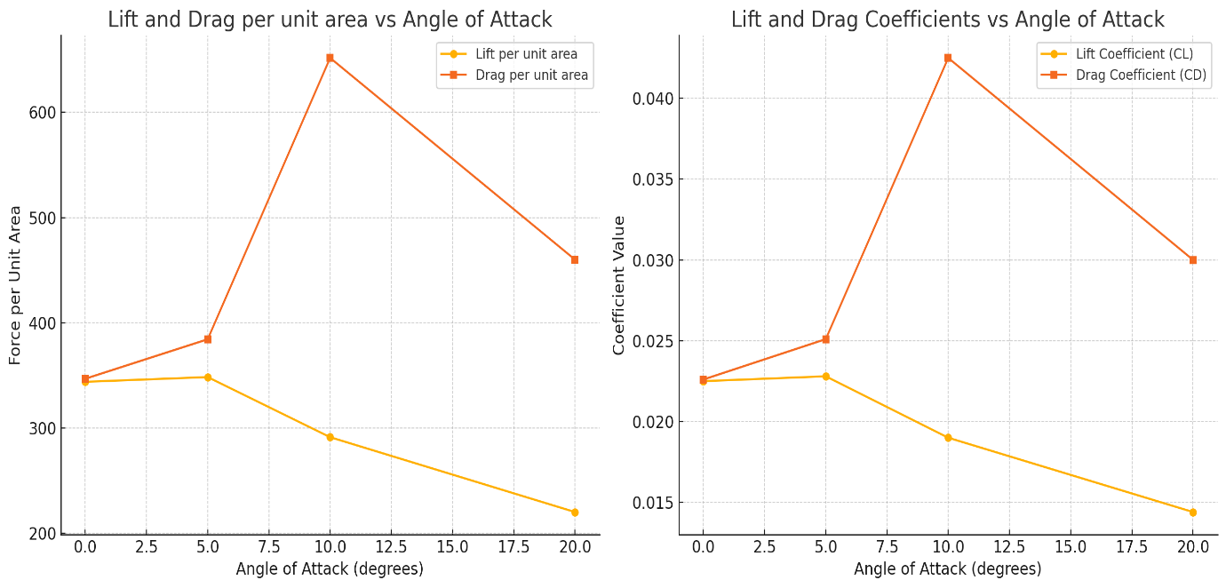

**Pressure Distribution:**

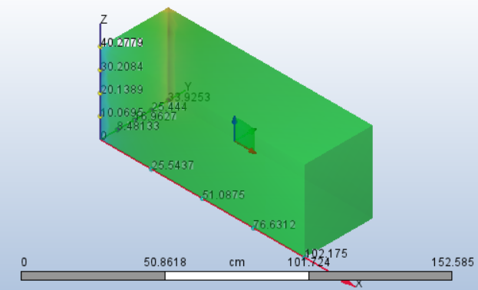 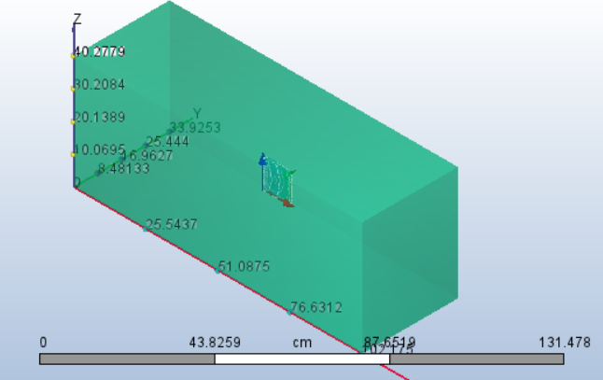

The above images show pressure contour at low and higher angle of attack respectively.

• **Interpretation :** The pressure contours clearly illustrate the mechanism of lift generation. At low angles, a distinct high-pressure region is visible at the stagnation point on the leading edge, while a large low-pressure (suction) region exists on the upper surface. During stall, this suction peak collapses, leading to the loss of lift.

**Flow Separation and Stall: 1.Pathlines/streamlines:** for attack of angle 5° and 20° respectively.

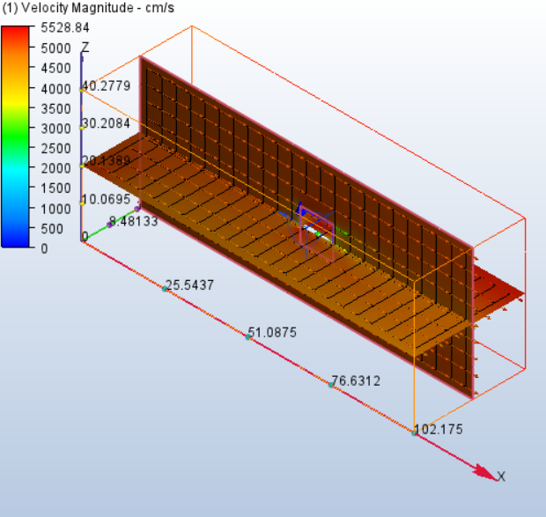 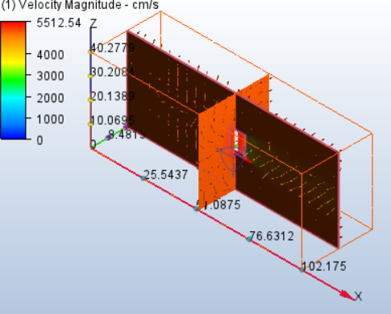

**Interpretation:** The stall is visualized as a massive flow separation from the aerofoil's upper surface which occurs in the higher angles, as seen in the images above. The velocity vectors confirm this, showing a region of reversed flow where the fluid is moving backward toward the leading edge. This recirculation bubble thickens the wake, causing a large increase in pressure drag and a loss of lift.

**5. Design Recommendations and Optimizations**

* **Optimal Operating Range:** Based on the analysis, the recommended operational range for this aerofoil is between 2° and 10°. Within this range, it produces consistent lift with high aerodynamic efficiency. The optimal angle for maximum efficiency (max L/D) is around 5-6 degrees.
* **Operational Limits:** The critical stall angle was determined to be 15 degrees and above. Operation beyond this angle must be avoided to prevent a sudden loss of lift and control.
* **Potential Optimizations and Further Work:**
  + **Shape Modification:** To improve performance, minor modifications to the aerofoil's leading-edge radius could be investigated to potentially delay the onset of flow separation and increase the stall angle.
  + **High-Lift Devices:** Further simulations could analyse the effect of adding high-lift devices, such as flaps or slats, to increase the maximum lift coefficient (CL, max​) for take-off and landing phases.
  + **3D Analysis:** A full 3D wing analysis could be performed to account for the effects of finite wing span and wingtip vortices, which would provide a more accurate prediction of overall aircraft performance.